**Mail Casting**

**Project Objective**

**A** mailer application for a company that can be used by the employees of the company only. It can be run on internet. Each user can send mails, receive mails and delete mails after getting logged in!

Any kinds of IDE can be used to develop the project such as eclipse, Net beans. Oracle 10g can be used for the database and Web logic, WebSphere or any other platforms can be used for server. The user can very easily send mails to particular persons over the domains, view received mails and even delete mails. Java server pages,AJAX and Java script are used as front end tool and Oracle is used as the back end tool.

Certain software requirements are there to run the project. In order to run the Mail Casting Project you first need to install any particular IDE among the most popular ones such as: eclipse, net beans. In order to meet the database requirement of the project, Oracle 10g database is used with a particular and specific username and password. Running the Mail Casting Project is very simple. All you need to do is import the file of the project on the IDE of your choice and then run it. The table creations will happen automatically for all the tables.

## ****Existing System****

In the existing Mail Casting Project system, if one has to send the mails to any one of the other, than he or she will have to keep all the addresses in their mind and along with them, if they want to mail, than they have to keep their id and password along with them. Existing Mail Casting Project system is quite an hectic task.

## ****Proposed System****

In the proposed Mail Casting Project system, the employees of the company can send the mails to all the clients via a single applications only. They just not need to login into all the stuffs for their gmail id and all the other relevant id’s in order to mail certain important documents or anything’s on their clients. Proposed Mail Casting Project system is very much useful for all the employees and all the workers as well as clients of the company.

## ****Mail Casting Snapshots****

[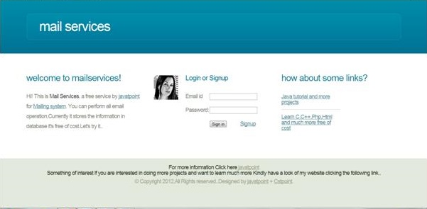](https://images.projectsgeek.com/2016/09/Mail-Casting-Project.jpg)

## ****Mail Casting Project Modules****

The employee or users module:

The user module or the employee module has the provision, where the employees or the users of the system can send emails intra organization to any person they wish to. The users of the Mail Casting Project system will also be able to view the names, employee designation and also display picture of the receiver if available. The receiver on the other end will also be able to view all these details of the sender. The employees can also make scheduled messages, meaning that they can choose a particular time and also on which particular date a message will be sent to a receiver or a cluster of receivers. The users can also send emails in any particular pre-defined format that are mostly required in any professional organization. A bunch of such professional email templates are also available.

## ****Software Requirements****

* Oracle
* Jdk
* Eclipse
* Netbeans
* notepad

## ****Hardware Requirements****

* Hard Disk – 2 GB.
* RAM – 1 GB.
* Processor – Dual Core or Above.
* Mouse.
* Keyboard.
* Monitor.
* Printer.

## ****Technologies Used****

* Java
* SQL
* JSP
* JavaScript
* Ajax